Out of the box, Docker creates three networks:

* bridge - An automatically generated network with a subnet and a gateway within a host
* host - Allows a container to attach to the host's network
* none - A container-specific network stack that lacks a network interface.

Docker connects to the bridge network by default; this allows deployed containers to be seen on your network. Let's see how we can manage those networks, create a new network, and then deploy a container on our new network.

**Viewing networks**

To view the current list of Docker networks, issue the command:

docker network ls

The above command will list out the Docker networks (**Figure A**).

**Figure A**

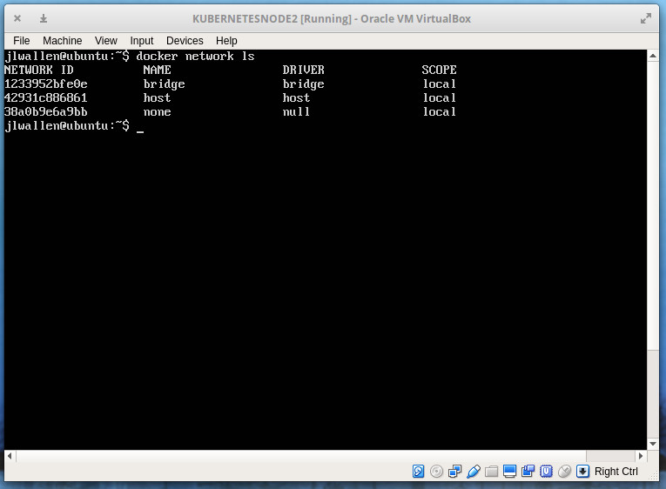

Our default Docker networks.

You can get more information on a particular network, by issuing the command docker network inspect NAME (Where NAME is the name of the network you want to view). If you want to view details on the bridge network, that command would be *docker network inspect bridge*. The output of that command would give you all the information you need about that network (**Figure B**).

**Figure B**

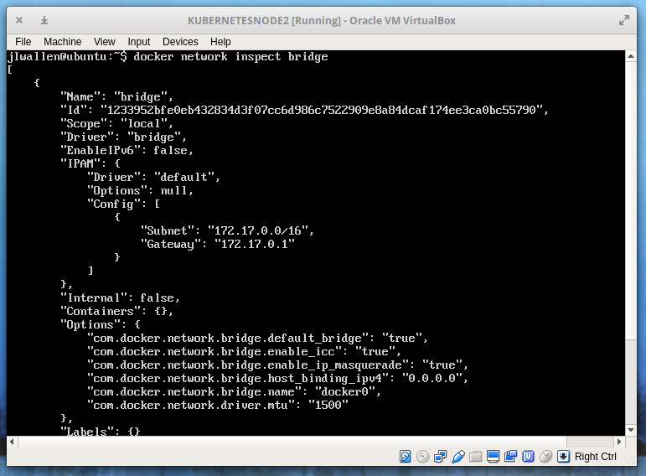

The bridge network information listing.

**Creating a new network**

I'm going to demonstrate how to create a bridge network and then show you how to deploy a container on that network. We'll create a network called isolated. The creation of this network can be achieved with a single command:

docker network create --driver bridge isolated

The output of that command will be a long string of characters that represents the ID of that newly-created network (**Figure C**).

**Figure C**

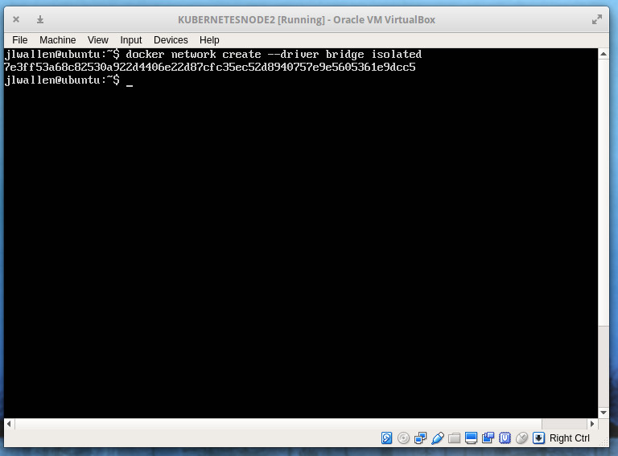

A newly created network.

Run the inspect command on that newly created network with the command docker network inspect isolated to see that our new network has been automatically given its own subnet and gateway (**Figure D**).

**Figure D**

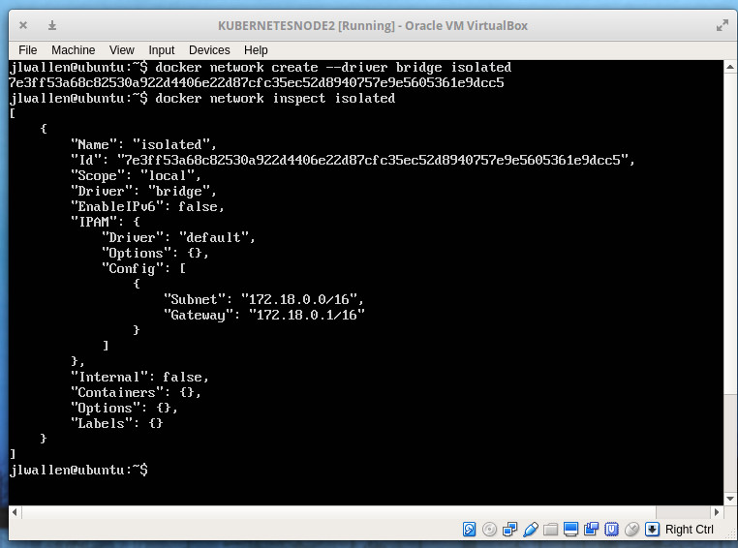

Our new network, named isolated.

But what if you want to create a network with a specific subnet and gateway? That's possible as well. Let's say you want to create a network with a subnet of 192.168.2.0/24, a gateway of 192.168.2.10, and the name new_subnet. The command for this would be:

docker network create --driver=bridge --subnet=192.168.2.0/24 --gateway=192.168.2.10 new_subnet

Once created, inspect the network, with the command*docker network inspect* *new_subnet* to see the results (**Figure E**).

**Figure E**

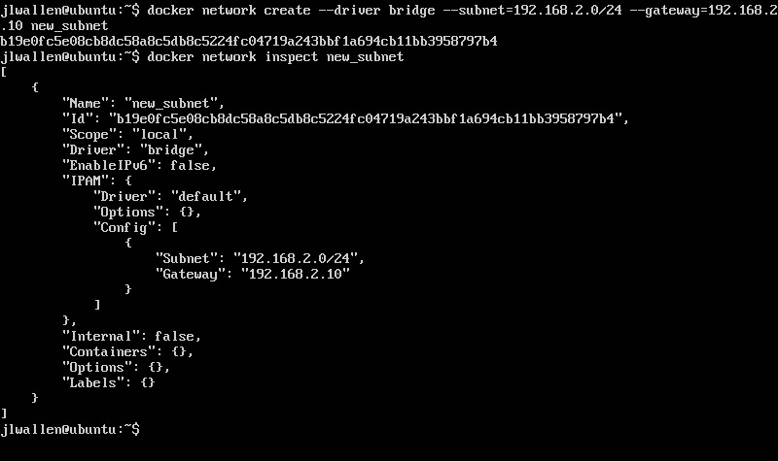

Our new network with a specific subnet and gateway.

**Attaching a container to a networking**

Let's attach a container to our newly created network. Say you've already pulled down the nginx image and want to launch a container, named docker-nginx, attached to the isolated network. To do this, the command would look like:

docker run --network=isolated -itd --name=docker-nginx nginx

If you now run the command docker network inspect isolated, you'll see that the container has been attached (**Figure F**).

**Figure F**

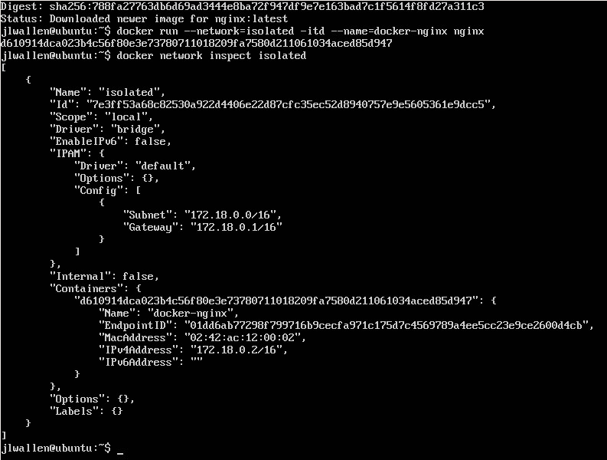

Our container has been attached.

Any other container you create on this network would be able to automatically connect to one another. So if you create a database container on isolated, it would be available for any other container on the same network.